September 25th, 2011
Hi
In between work on the Singapore books, I am typing up my old diaries from notebooks (real notebooks!) to computer. I am up to 2002, though there are big gaps with many years with nothing. About 2004, I downloaded a desktop diary and since then have not used pen-and-paper diaries. But there does seem to be a downside to this. Although the entries in my notebooks are not usually long, I often did include notes on important things that happened in HK and the world. This was probably because I would write up the diaries in the evening while watching the news. However, with the desktop calendar, this stopped as I made entries in the mornings when I turned on the computer so did not make such entries unless they especially stuck in my mind.
Just over a week ago, there was a huge cocaine bust in HK; about 600 kg, with an estimated street value of $600 million. This was the biggest haul ever in HK and was even mentioned on the Australian TV news. The gang consisted of 1 person from the US, 5 from Mexico and 1 from Columbia. One was a woman who would carry her baby around to avoid suspicion. They would send the cocaine to HK with plastic for recycling and had it stored in a plastic recycling warehouse in Tuen Mun.
This past week I did a lot of swimming, more than I had planned. I mentioned that my average swim last year was 2.2 km and that so far this year it is a tad under 2 km. Well, I decided to aim for the 2.2 average this year in the remaining swims, which means increasing the distance for the remaining swims substantially. Well, this week I did 19.3 km with Friday's swim being 6 km (rather than the 2.7 km planned!). I just decided to keep going and after the 3 km mark, it actually got easier - very easy at times, and all overarm. The 6 km is my PB I think. (Sorry Nadine, I used a shorthand which may not be 'obvious'; I hope you know what this one means.) Still, again I am reminded of how little 6 km actually is . Right at this moment, a 61-year old lady from LA is swimming the 166 km from Florida to Cuba (and without a shark cage and suffering from many jellyfish bites and the occasional curious shark). She stops occasionally for a rest and for food, but does not get out of the water.
In HK this week, the issue of paternity leave was raised again. Most people seem to be in favour of it but the questions remain of how long (shortest being just 2 days) and who will pay for it (employers do not want to, and especially just after the minimum wage came in). In HK, there has also been an increase in the number of free newspapers being issued. Most are distributed at bus and train stops. Well, it turns out that many old people are collecting these, often multiple copies, not to read but to sell recyclers! So, a lot of the recycled paper in HK is coming from paper that need not have been used in the first place.

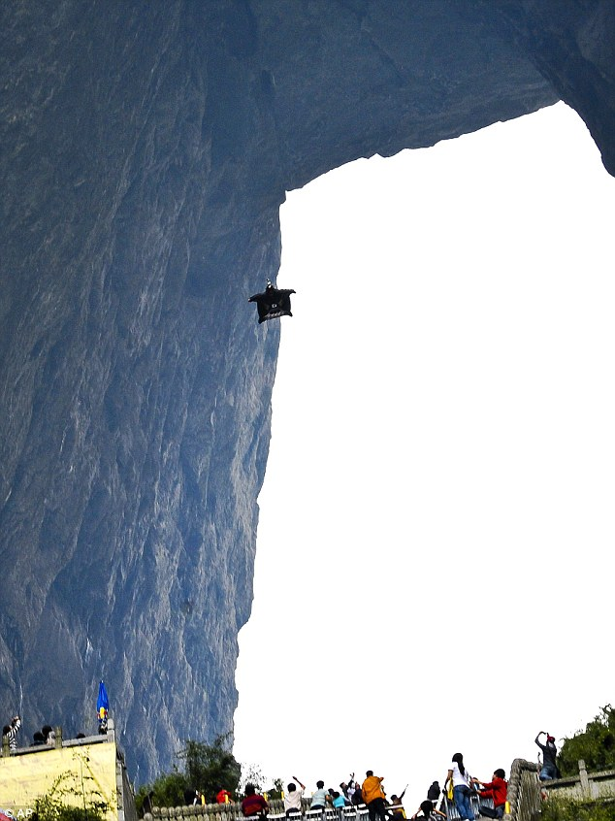
Were any of you affected by those bits of that satellite that fell to earth. They are not sure where they fell but the Pacific Ocean (and Hawaii) and parts of Canada (and Boston is close to Canada) could have been hit.
Also, did you see the pictures of the man in a wingsuit who dropped from a helicopter and flew through a cave/hole in a hill in China that was just 96 feet wide? Spectacular indeed! Have a look at the pictures and the video at:
http://www.dailymail.co.uk/news/article-2041434/Wingsuit-stuntman-Jeb-Corliss-shoots-narrow-slit-Tianmen-mountain-75mph.html
http://www.youtube.com/watch?v=6t0xqNln5RU&feature=player_embedded
I heard on the news yesterday that Putin is to stand again for president of Russia, something he coveted a lot! He is really a throwback to the Soviet era.
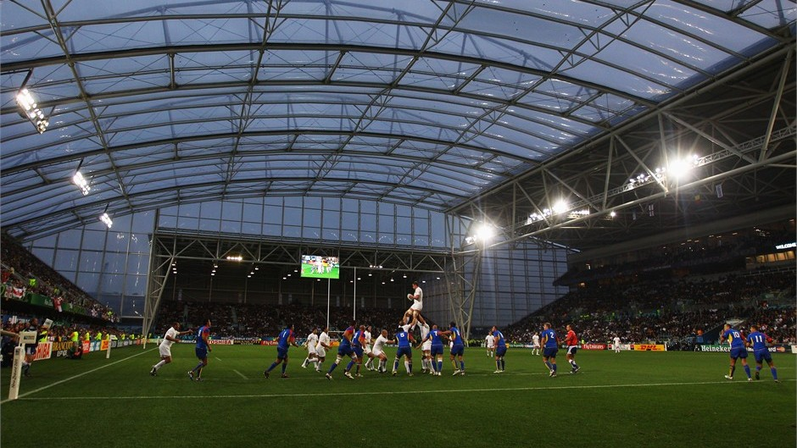
The RWC continues. Yesterday, NZ easily beat France 37-17. NZ and France should finish first and second respectively in their pool. The NZ captain played his 100th game for the ABs. There was much criticism of the French coach who left out several of his best players - against the All Blacks and in a World Cup competition too. Why? Because the loser - and so the runner up in the pool - will have an easier time in the knock-out stages to get into the final; they will avoid Australia or South Africa whom the ABs will meet. Even one past AB (Zinzan Brooke - heard of him?) suggested that NZ 'throw' the match for the same reason. (And a pic of the new stadium at Dunedin - game is between England and Romania.) And the USA were well beaten by Australia 67 - 5. More pics and news at the iRB site:
http://www.rugbyworldcup.com/index.html
That’s about it for now.
Cheers

